Big Mountain Resort

Big Mountain Resort is not fully taking advantage of its facilities and is losing revenue every season. We understand that the resort’s pricing strategy is charging a premium above the average price of other resorts in its market segment. We have modeled different scenarios and situations and think we have found a way for Big Mountain Resort to gain additional revenue while increasing ticket prices.

Our team has gone through the data and compared pricing against other resorts. We had to clean the data and make sure that the data was going to give us an accurate model. While cleaning the data, we decided to compare the average ticket price by State.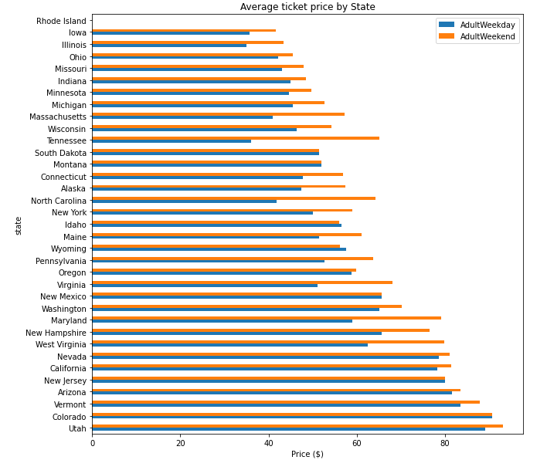



You can see from the graph that Montana’s weekday and weekend pricing is relatively low on the chart compared to other states.

We also wanted to look at other parameters, not just ticket pricing, to see how we compare against the other resorts. We saw a strong correlation when comparing ticket prices with vertical drop, fast quads, total runs, and chairs. This comparison used all of the resorts and not just Big Mountain Resort.

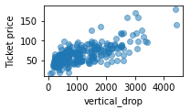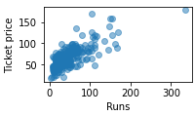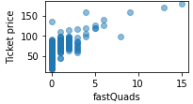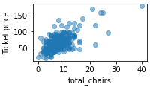

After collecting all of this data, we decided to use a technique that allows us to evaluate our algorithm. Before running the test, we calculated the average ticket price of $63.81. Our tests told us that we would be off around $19 if we guessed the ticket price based on the average ticket price. We needed to be more confident, so we continued to run other tests. Through multiple tests, we could reduce it from $19 to $9. We also wanted to make sure that we had enough data. We were worried that not having enough data would give us skewed results. We found out that we had enough data to make a good recommendation.

After confirming that we had enough data and it was accurate, we modeled the results. We looked at ticket price, adult weekend ticket price, vertical drop, snow-making area, the total number of chairs, fast quads, runs, longest run, trams, and skiable terrain area.

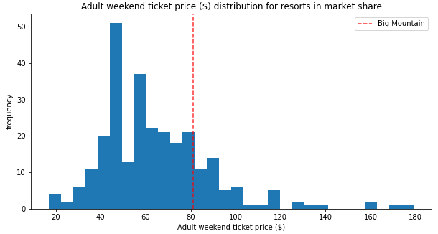

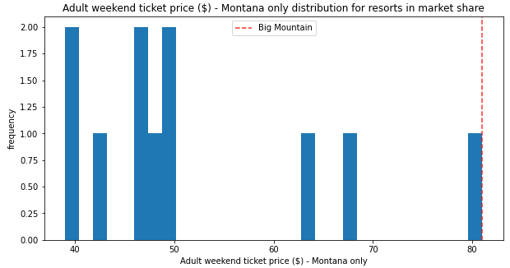

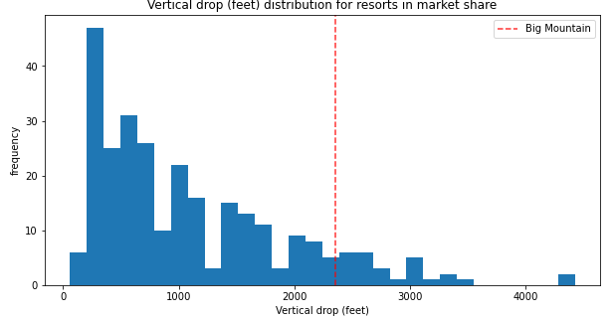

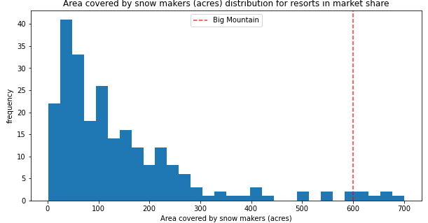

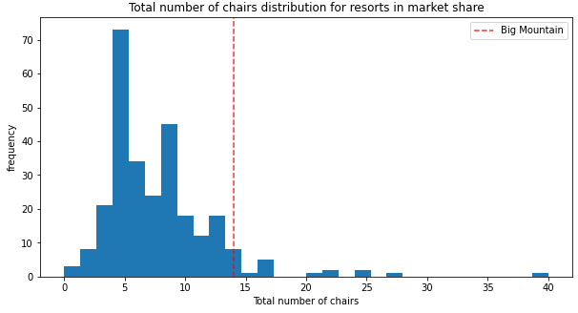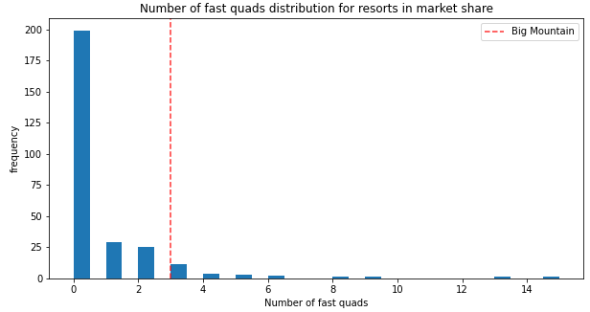

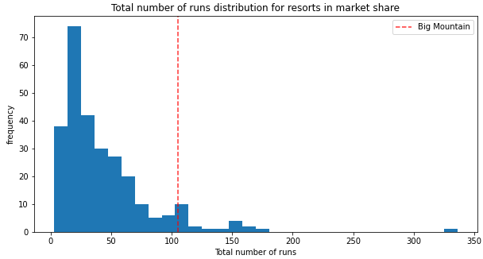

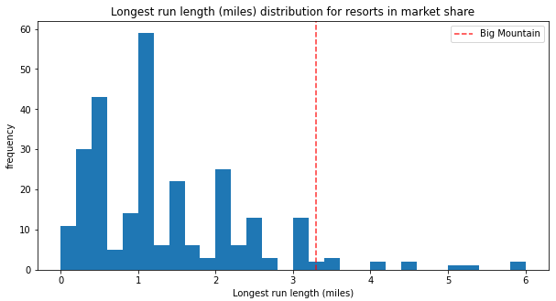

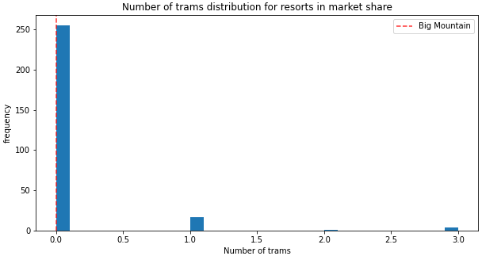

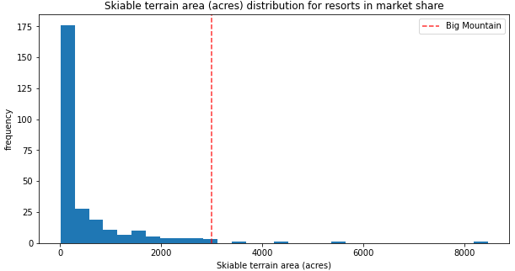

The red line in the charts above indicates how Big Mountain Resort compares to its peers. Big Mountain Resort is either the same or better than most competitors, even though the prices are lower than most resorts.

After the modeling, we need to increase our ticket prices from $81.00 to $95.87. Even when we have a margin of error of $10.39, we still recommend increasing the ticket prices. When looking at the different scenarios given to us by the leadership team, here are our findings.

1. Permanently closing down up to 10 of the least used runs. This doesn't impact any other resort statistics.
   1. If we close one run, it will not affect ticket price or revenue. Closing down 2 or 3 will decrease our revenue and ticket prices. If we close down 3, closing down, 4, or 5 will not reduce ticket price or revenue. After closing down six, we will see a significant gain and ticket price reduction.
2. Increase the vertical drop by adding a run to a point 150 feet lower down but requiring the installation of an additional chair lift to bring skiers back up without additional snowmaking coverage
   1. If we go with this scenario, we could increase ticket prices by $1.99, increasing revenue to $3,474,638 over the season.
3. Same as number 2, but adding 2 acres of snowmaking cover
   1. This scenario will result in the same ticket price increase and revenue as scenario 2. It does not make a difference to add 2 acres of snowmaking cover.
4. Increase the longest run by 0.2 miles to boast 3.5 miles length, requiring additional snowmaking coverage of 4 acres
   1. This scenario makes no difference; it will not increase ticket prices or revenue.

We recommend option two because it will increase revenue and the ticket price. The other options either do not increase revenue or will decrease revenue.

After the analysis, we recommend that the company increase its ticket prices up to $95.87 and Increase the vertical drop by adding a run to a point 150 feet lower down but requiring the installation of an additional chair lift to bring skiers back up without additional snowmaking coverage. This model will increase both ticket prices and revenue. If you have further inquiries on anything else, feel free to reach out to us.